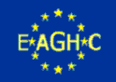  
  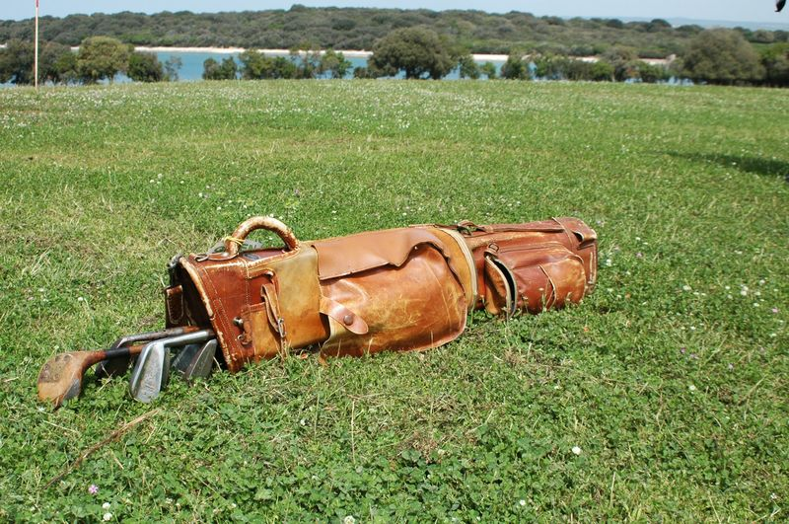
  July 8th, 2017
  3RD brioni hickory open championship
  Announcement
  We are very happy to announce that the 3rdBrioni Hickory Open Championship will take place on eight of July 2017 on the Old Golf Course Brioni.
  Friday 07th
  Practice round on the Old Golf Course (individual arrangements)
  Free tour of the Brioni Main Island
  Saturday 8th
  10:30 BHOC 2017
  16:30 Drink at the Clubhouse
  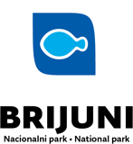
  19:00 Dinner at the Neptun hotel – prize ceremony
  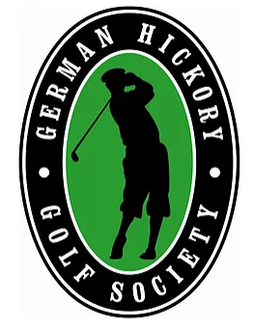
  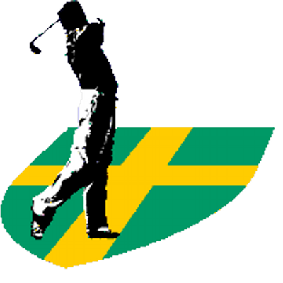
  18 hole stroke play
  historic 1922 golf course with sand greens
  PROGRAMME OF THE BHOC TO FOLLOW
  Organizators:
  Golf klub Pula
  Istarski golf savez
  Suppoerted by:
  National Park Brioni
  EAGHC
  GHGS
  Registrations at:
  Damir Ritosadamir.ritosa@gmail.comDavor Pikotdavorpikot@gmail.comChristoph MeisterCNMeister@golfika.de

